CREATE JAVA APPLICATION

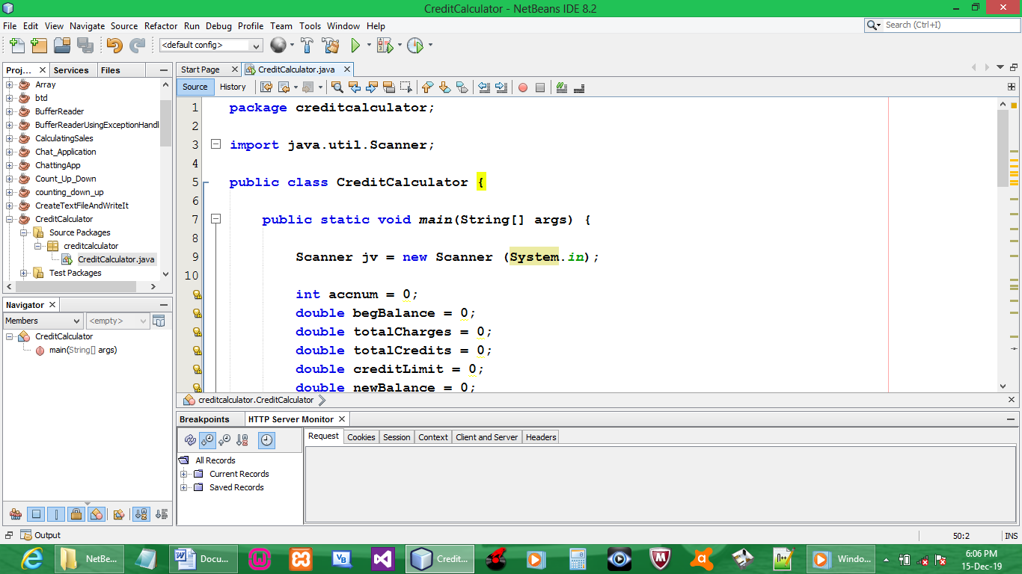

CODE:

package creditcalculator;

import java.util.Scanner;

public class CreditCalculator {

public static void main(String[] args) {

Scanner jv = new Scanner (System.in);

int accnum = 0;
double begBalance = 0;
double totalCharges = 0;
double totalCredits = 0;
double creditLimit = 0;
double newBalance = 0;

System.out.println("Please enter Customer Account Number (or -1 to quit): ");
accnum = jv.nextInt();

System.out.println("Please enter Customer Beginning Balance: ");
begBalance = jv.nextDouble();

System.out.println("Please enter Total Charges: ");
totalCharges = jv.nextDouble();

System.out.println("Please enter Total Credits: ");
totalCredits = jv.nextDouble();

System.out.println("Please enter Customer Credit Limit: ");
creditLimit = jv.nextDouble();

newBalance = begBalance + totalCharges - totalCredits;

System.out.print("Account: " + accnum + "\n");
System.out.print("Credit Limit: " + creditLimit + "\n");
System.out.print("Balance: " + newBalance);

System.out.println();

if (newBalance > creditLimit){
System.out.print("Credit Limit Exceeded");
}
else {
System.out.print("Credit Limit NOT Exceeded");
}
System.out.println();
}
}

OUTPUT:

